Rampant Wear “Pre-Order” Form
First Name: _________________________Last Name: ________________________________
Students Name: _____________________Email address: ______________________
Phone to be reached for questions: ____________________________
Item ______________________________________________________________
□1/4th Zip Cadet Sweatshirt □Male □Grey □Small □$35
□Female □Black □Mediu
□Navy □Large □X Large
□2X Large
□3X Large*$2.00 extra □$2

Item _______________________________________________________________
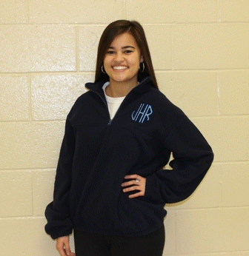
□1/4th Zip Fleece Jacket □Male □Navy □Small □$35
□Female □Black □Medium
□Large
□X Large
□2X Large
□3X Large*$2.00 extra □$2

Item requested: _________________________________ ______
Charles Rivers Rain-jacket □Male □Small □$35
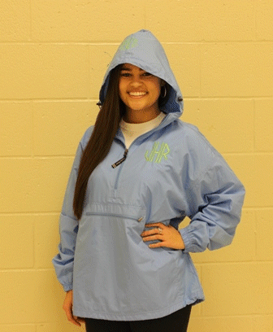
□Female □Medium
□Large
□X Large
□2X Large
□3X Large*$2.00 extra □$2

Item requested: _____________________________________
□ Spirit T-Shirt □Small □$35
□Medium
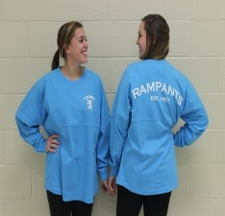
□Large
□X Large
□2X Large
□3X Large*$2.00 extra □$2

Total Amount Paid (order must be pre-paid) $_____

